Practicum Case | 
COMP7116 | COMP7116001 | COMP7116016 | MATH6168 | MATH6168016
Computer Vision
Computer Science | O221-COMP7116-NC01-08
Valid on Odd Semester 2024/2025 | Revision 00

Learning Outcome
- LO1 – Describe various computational principles and standard image processing operators in computer vision

Topic
- Session 8 – Image Recognition

Sub Topics
- Bag of Visual Words
- Classifier

Soal
Case
NCHardware
NCHardware is a hardware shop that sells a variety of peripherals such as keyboards, mices, headphones, and GPUs. The owner of the shop is currently looking to hire a programmer to make an image recognition program. The program must be able to identify various types of hardwares in order to ease the burden of the workers at NCHardware, which are currently categorizing the hardwares that they are selling manually one by one. As a programmer and a close friend of the owner, you offered to make the program using Python to help the owner.
- Image Recognition
- Make a program that can perform image recognition using the bag of visual words technique by extracting the features to capture distinctive features in the images, you can use the SIFT algorithm to achieve this. Then, cluster them using the k-means algorithm to obtain visual words which will represent the key features in the dataset. After clustering, you can normalize the features vectors using StandardScaler and train the classifier using the normalized features, you can use a linear Support Vector Machine (SVM) classifier for the model. Lastly, display the testing results and make sure that the results are correct.
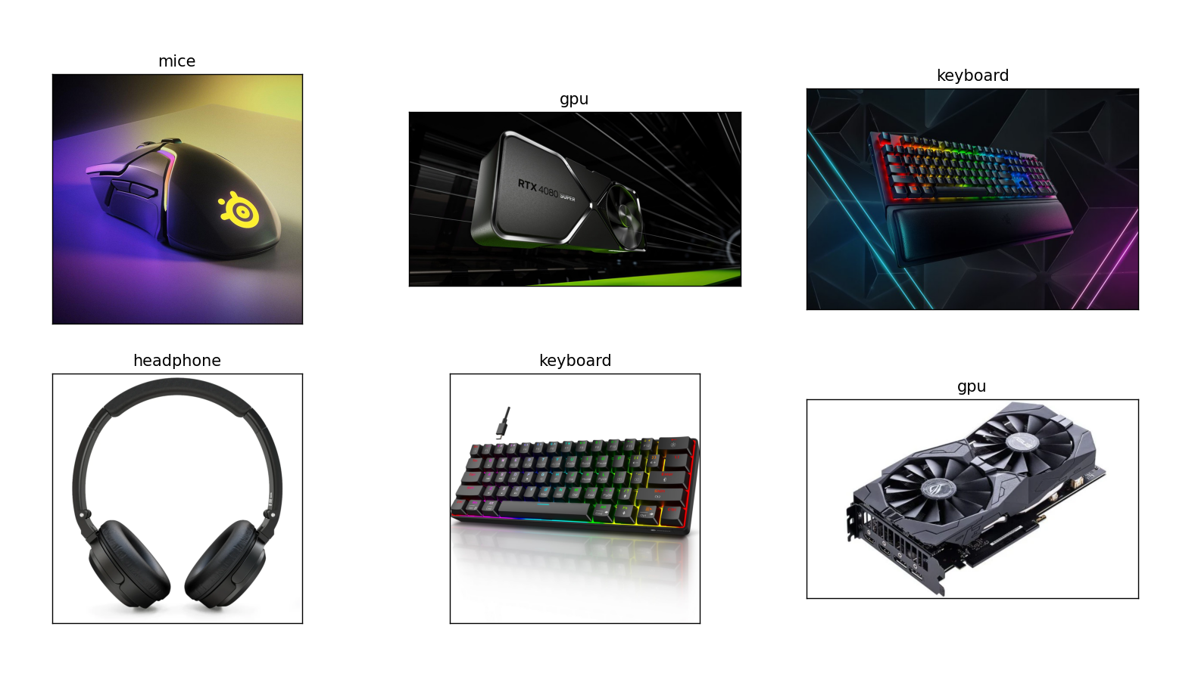
Figure 1. Example of Image Recognition Testing Result

